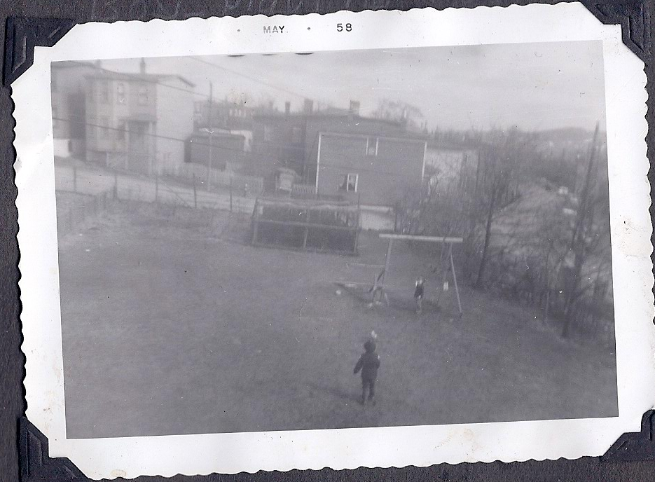

the grounds of 106 Pennywell Road from the bedroom window looking east

3/4 - the Green Gate with just a tiny triangle of the Thistle Yard to the upper left
swings/seesaw and pine hatchery in background
houses of Linscott Street behind

